Cloud Security Capstone Project
Secure Three-Tier Application on AWS using Terraform
Name: Sanika Kadam
PRN: 2124UCSF1112

1.Introduction
Cloud computing provides scalable and flexible infrastructure for hosting modern applications. However, deploying applications without proper security configurations can expose sensitive information and create security risks.
This project focuses on designing and deploying a Secure Three-Tier Application on Amazon Web Services (AWS) using Terraform. The architecture consists of three major layers: the Presentation Layer, Application Layer, and Database Layer.
The project uses Amazon VPC to create an isolated network environment with public and private subnets. An Application Load Balancer (ALB) is deployed in the public subnets to receive incoming user requests. The application server is deployed on an EC2 instance in a private application subnet, while Amazon RDS is deployed in private database subnets.
Security is implemented using Security Groups, Network Access Control Lists, Internet Gateway, NAT Gateway, and private route tables. Additionally, VPC Flow Logs and AWS CloudTrail are configured to monitor network traffic and record account activities.
Terraform is used as Infrastructure as Code (IaC) to automate the creation and management of AWS resources.

2. OBJECTIVES
- To design and deploy a secure three-tier architecture on AWS.
- To create a Virtual Private Cloud (VPC) with public and private subnets using Terraform.
- To deploy an Application Load Balancer in public subnets.
- To host the application server on a private EC2 instance.
- To configure Amazon RDS in private database subnets.
- To implement secure communication using AWS Security Groups and route tables.
- To enable VPC Flow Logs and CloudTrail for security monitoring.
- To automate AWS infrastructure deployment using Terraform.

3. TECHNOLOGIES AND SERVICES USED
Technology / Service | Purpose
Amazon Web Services (AWS) | Cloud infrastructure
Terraform | Infrastructure automation
Amazon VPC | Isolated network environment
Public Subnet | Hosts internet-facing resources
Private Subnet | Hosts application and database resources
Application Load Balancer | Distributes incoming application traffic
Amazon EC2 | Hosts the application
Amazon RDS | Database management
Internet Gateway | Provides internet connectivity to public resources
NAT Gateway | Allows private resources to access the internet outbound
Security Groups | Controls inbound and outbound traffic
Route Tables | Controls network traffic routing
VPC Flow Logs | Monitors network traffic
AWS CloudTrail | Records AWS account activities
4.SYSTEM ARCHITECTURE
The proposed architecture follows a three-tier model consisting of the following layers:
4.1 Presentation Layer
The presentation layer handles incoming requests from users. An Application Load Balancer is deployed in the public subnets to receive HTTP/HTTPS requests and distribute traffic to the application server.
4.2 Application Layer
The application layer contains an Amazon EC2 instance deployed inside a private application subnet. The EC2 instance processes user requests received through the Application Load Balancer.
The EC2 instance is not directly accessible from the public internet. It accepts application traffic only from the Application Load Balancer's security group.
4.3 Database Layer
The database layer uses Amazon RDS deployed in private database subnets. It stores application-related information securely.
The RDS instance is configured with public accessibility disabled. Database connections are permitted only from the application server's security group.
4.4 Architecture Diagram
Traffic Flow:
Internet → Internet Gateway → Application Load Balancer → Private EC2 Application Server → Private Amazon RDS Database.
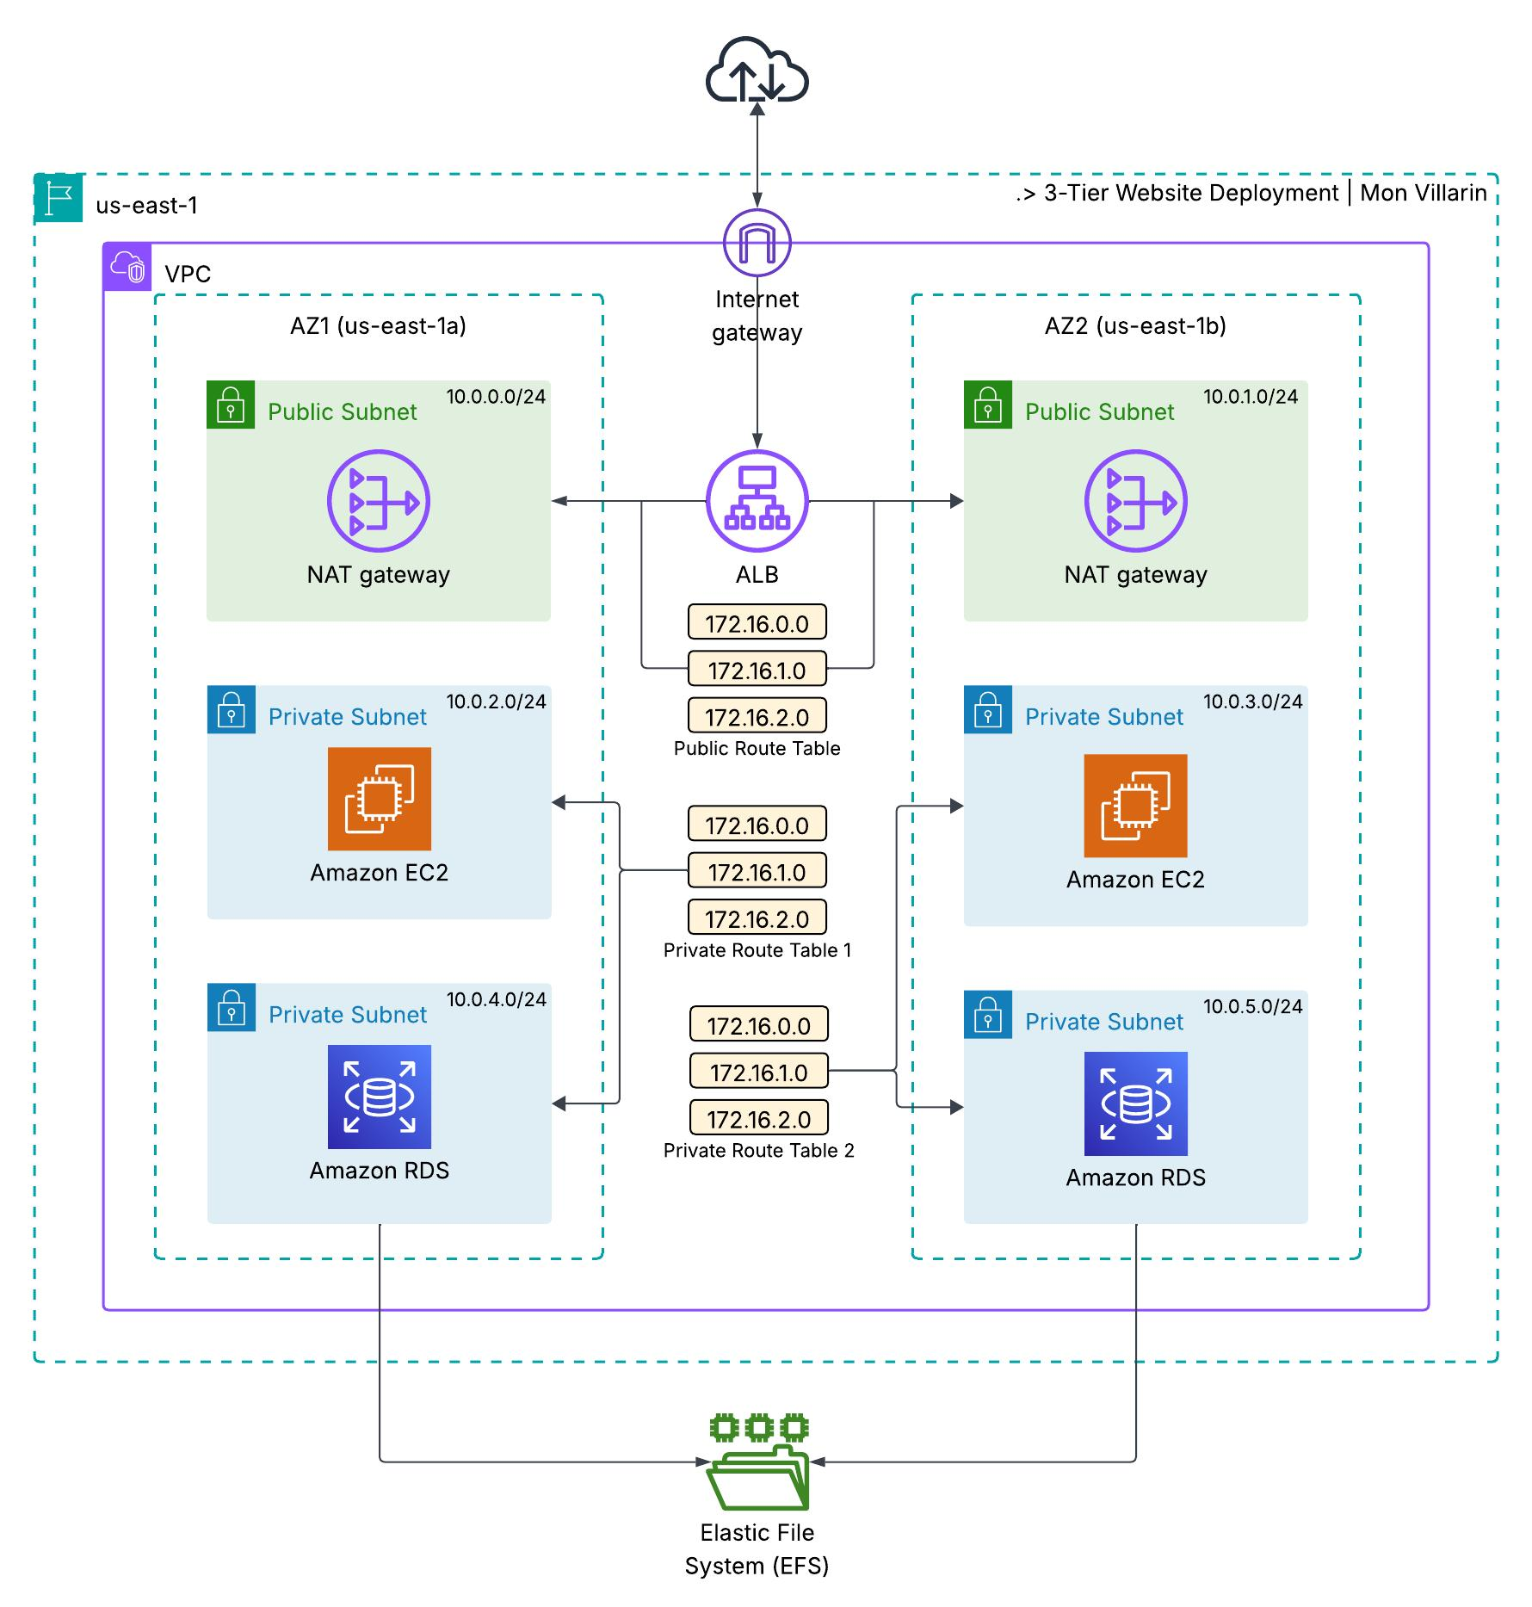
Architecture of the secure three-tier deployment
Tier | Subnets | Resources | Internet route
Web | Public: 10.0.1.0/24, 10.0.2.0/24 | Application Load Balancer, NAT Gateway | Yes, through the Internet Gateway
Application | Private: 10.0.2.0/24, 10.0.3.0/24 | EC2 server (no public IP) | Outbound only, through the NAT Gateway
Database | Private: 10.0.4.0/24, 10.0.5.0/24 | RDS MySQL | None

5. Terraform Implementation
TERRAFORM IMPLEMENTATION
The infrastructure is divided into nine Terraform configuration files. Each file manages a specific part of the AWS architecture, making the project easier to understand, maintain, troubleshoot, and review.
5.1 Terraform File Structure
The following nine Terraform files are used in the project:
File Name | Description
versions.tf | Defines Terraform and AWS provider versions and default resource tags.
variables.tf | Defines input variables such as AWS region, Availability Zones, CIDR ranges, and EC2 instance types.
network.tf | Creates the VPC, six subnets, Internet Gateway, NAT Gateway, and three route tables.
security_groups.tf | Creates ALB, application, and database security groups with security group-to-security group rules.
alb.tf | Creates the Application Load Balancer, target group, and HTTP listener.
compute.tf | Deploys the EC2 application server and creates an IAM role for AWS Systems Manager Session Manager.
database.tf | Creates the Amazon RDS MySQL instance and database subnet group.
monitoring.tf | Configures VPC Flow Logs with CloudWatch Logs and AWS CloudTrail with a private S3 bucket.
outputs.tf | Displays important deployment information such as the ALB URL, EC2 instance ID, RDS endpoint, log group name, and S3 bucket name.
5.2Terraform Deployment Workflow
The infrastructure is deployed using the standard Terraform workflow.
Step 1: Initialize Terraform
terraform init
Initializes the Terraform working directory and downloads the required AWS provider plugins.
Step 2: Validate Configuration
terraform validate
Checks the Terraform configuration files for syntax errors and configuration issues.
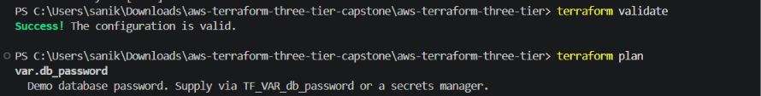

6. Deployment Evidence
The screenshots below were taken from the AWS Console (region Asia Pacific (Sydney)) and the terminal after terraform apply completed.

6.1 Terraform apply and application
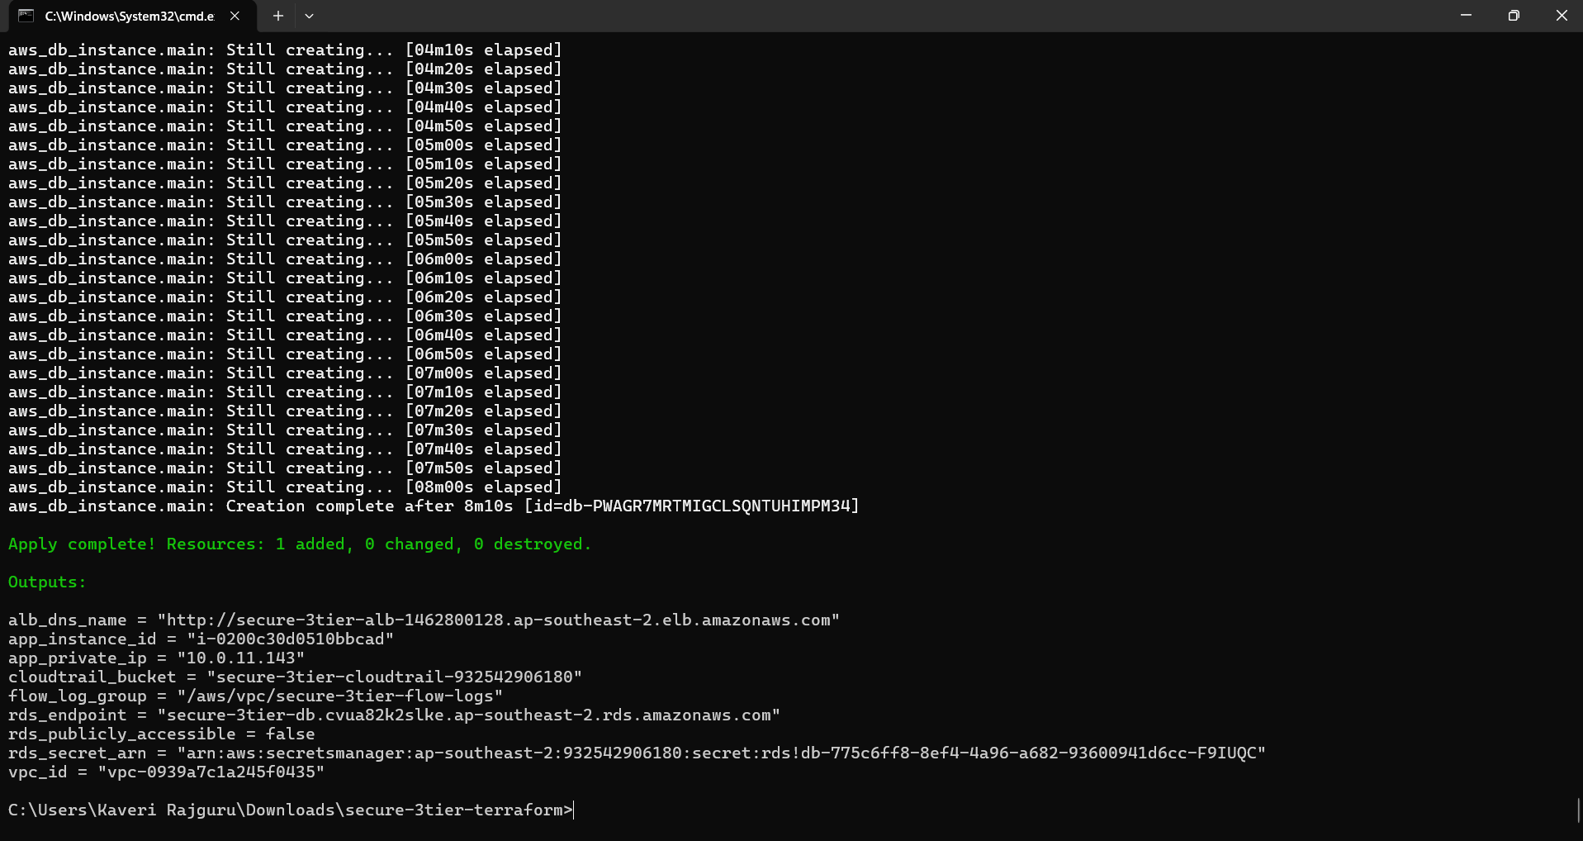
terraform apply finished successfully and printed the ALB URL, instance ID, RDS endpoint and log group.
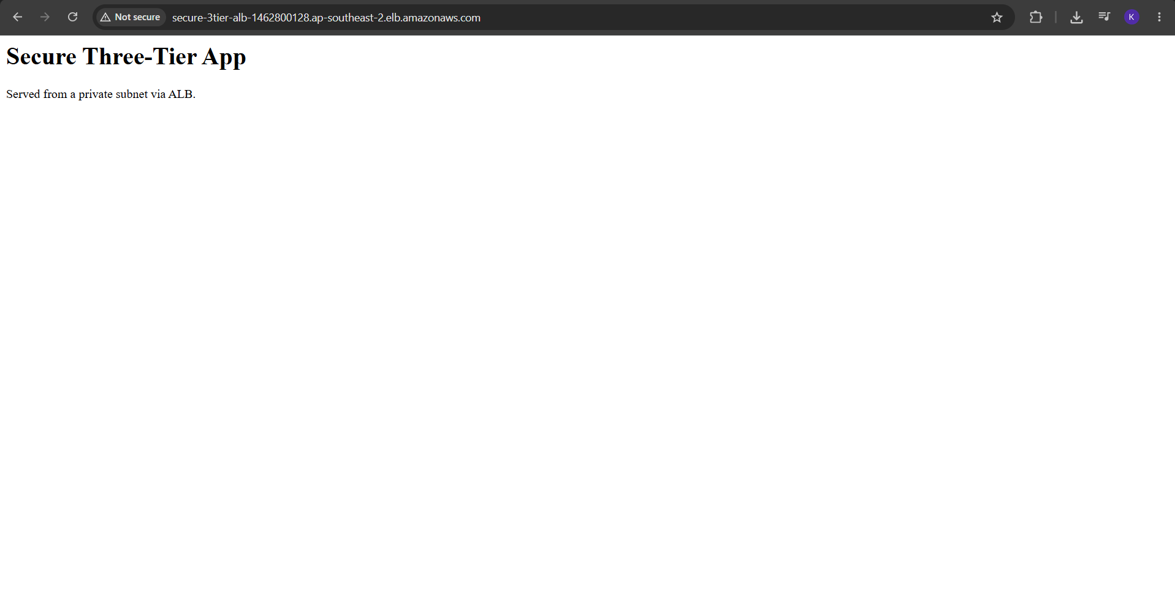
The application page, served from a private subnet, loads through the ALB DNS name.

6.2 Network: VPC, subnets, gateways and routes
-+
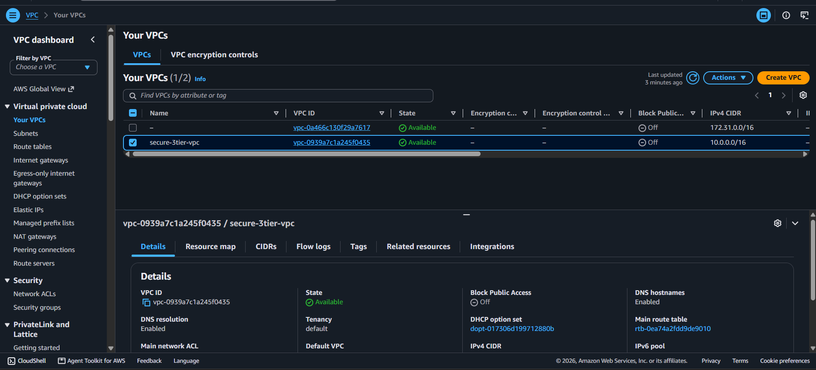
secure-3tier-vpc with CIDR 10.0.0.0/16.
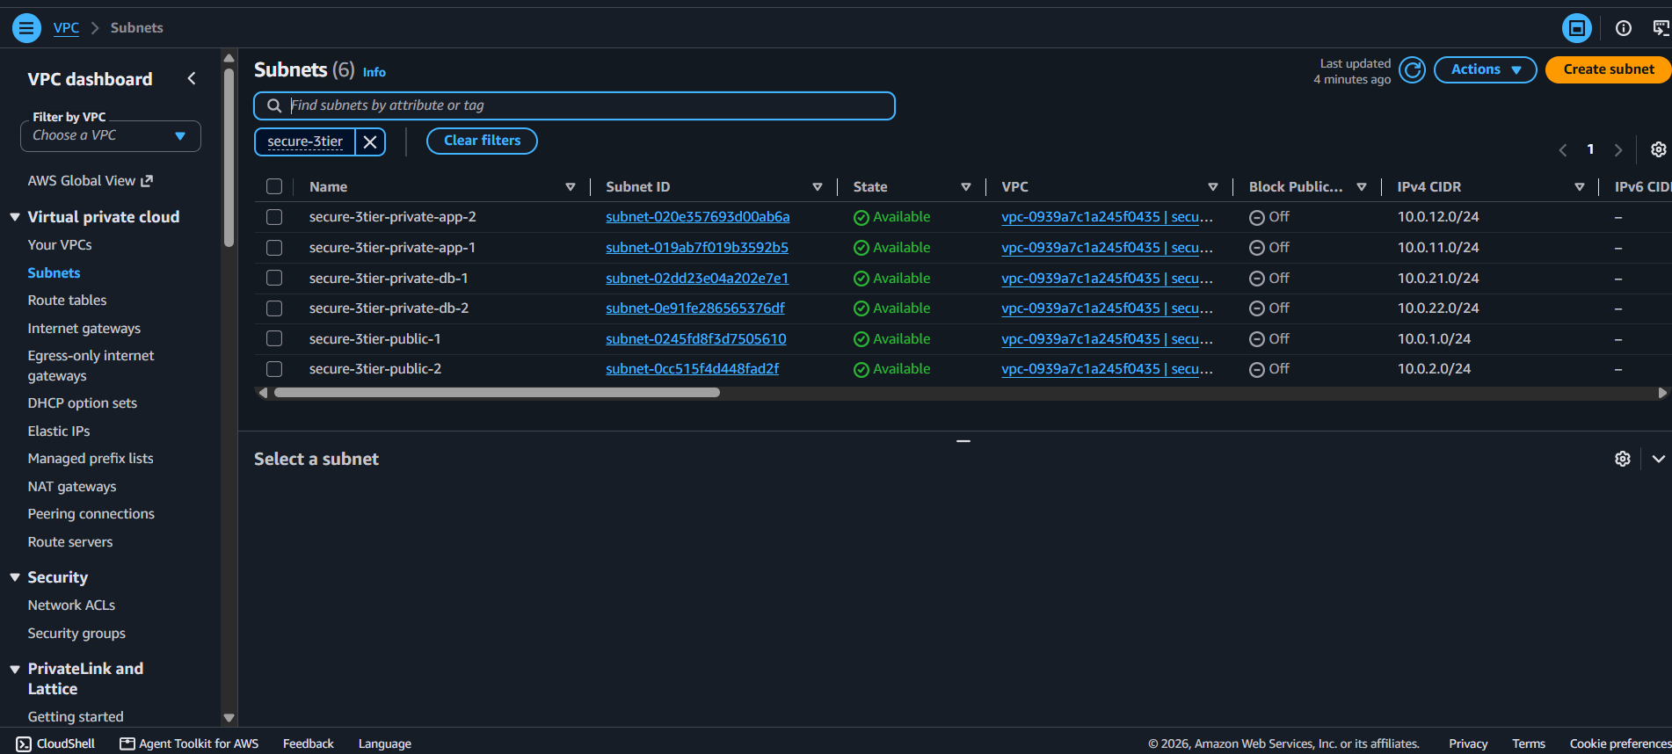
Six subnets across two availability zones: public, private-app and private-db.
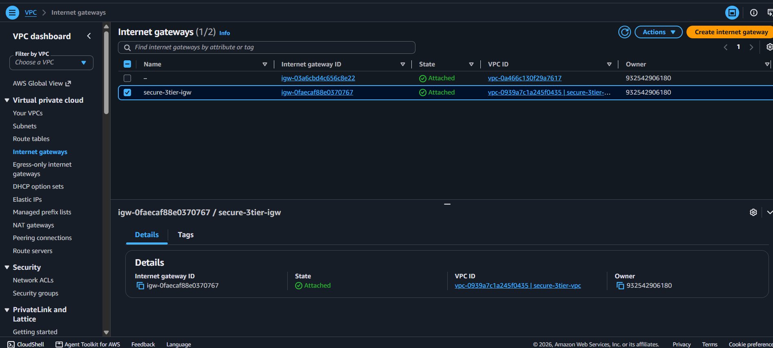
The Internet Gateway is attached to the VPC.
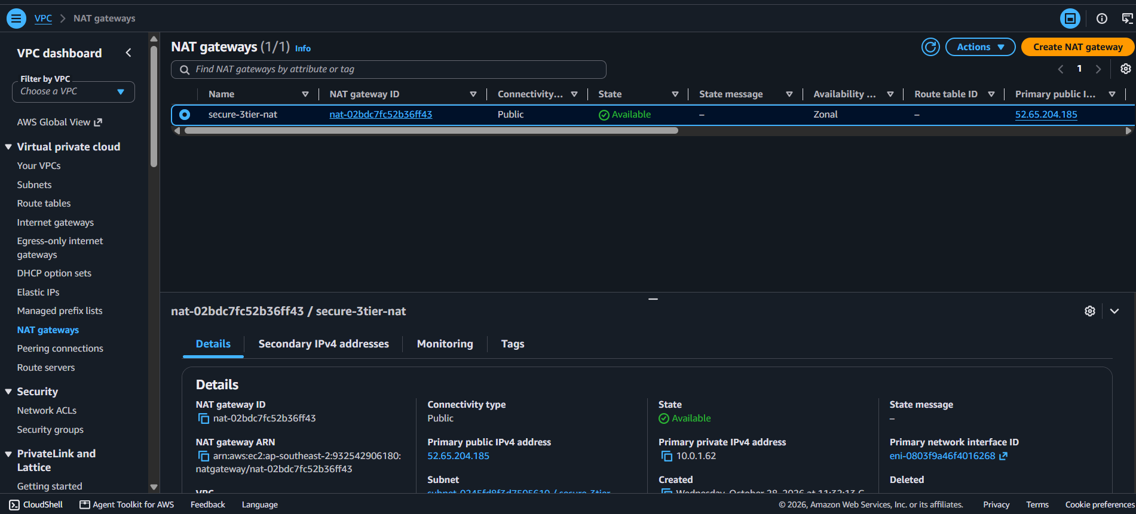
The NAT Gateway is Available in a public subnet with an Elastic IP.
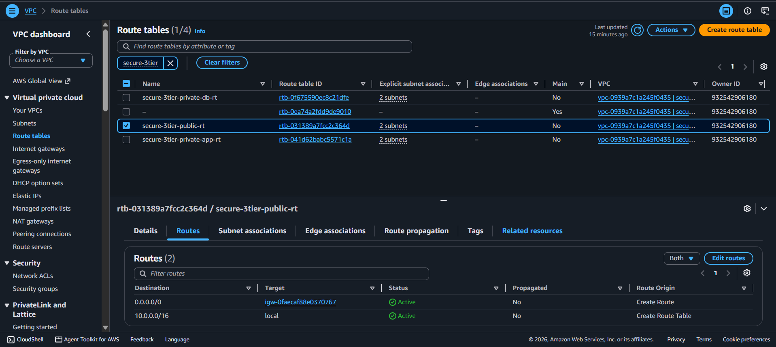
Public route table: 0.0.0.0/0 goes to the Internet Gateway.
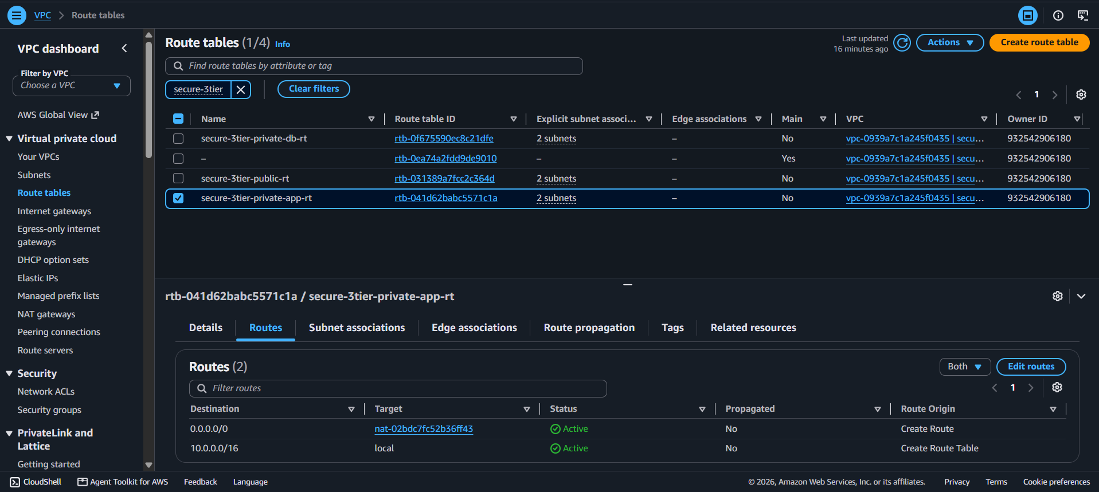
Application route table: 0.0.0.0/0 goes to the NAT Gateway, so the server can make outbound requests only.
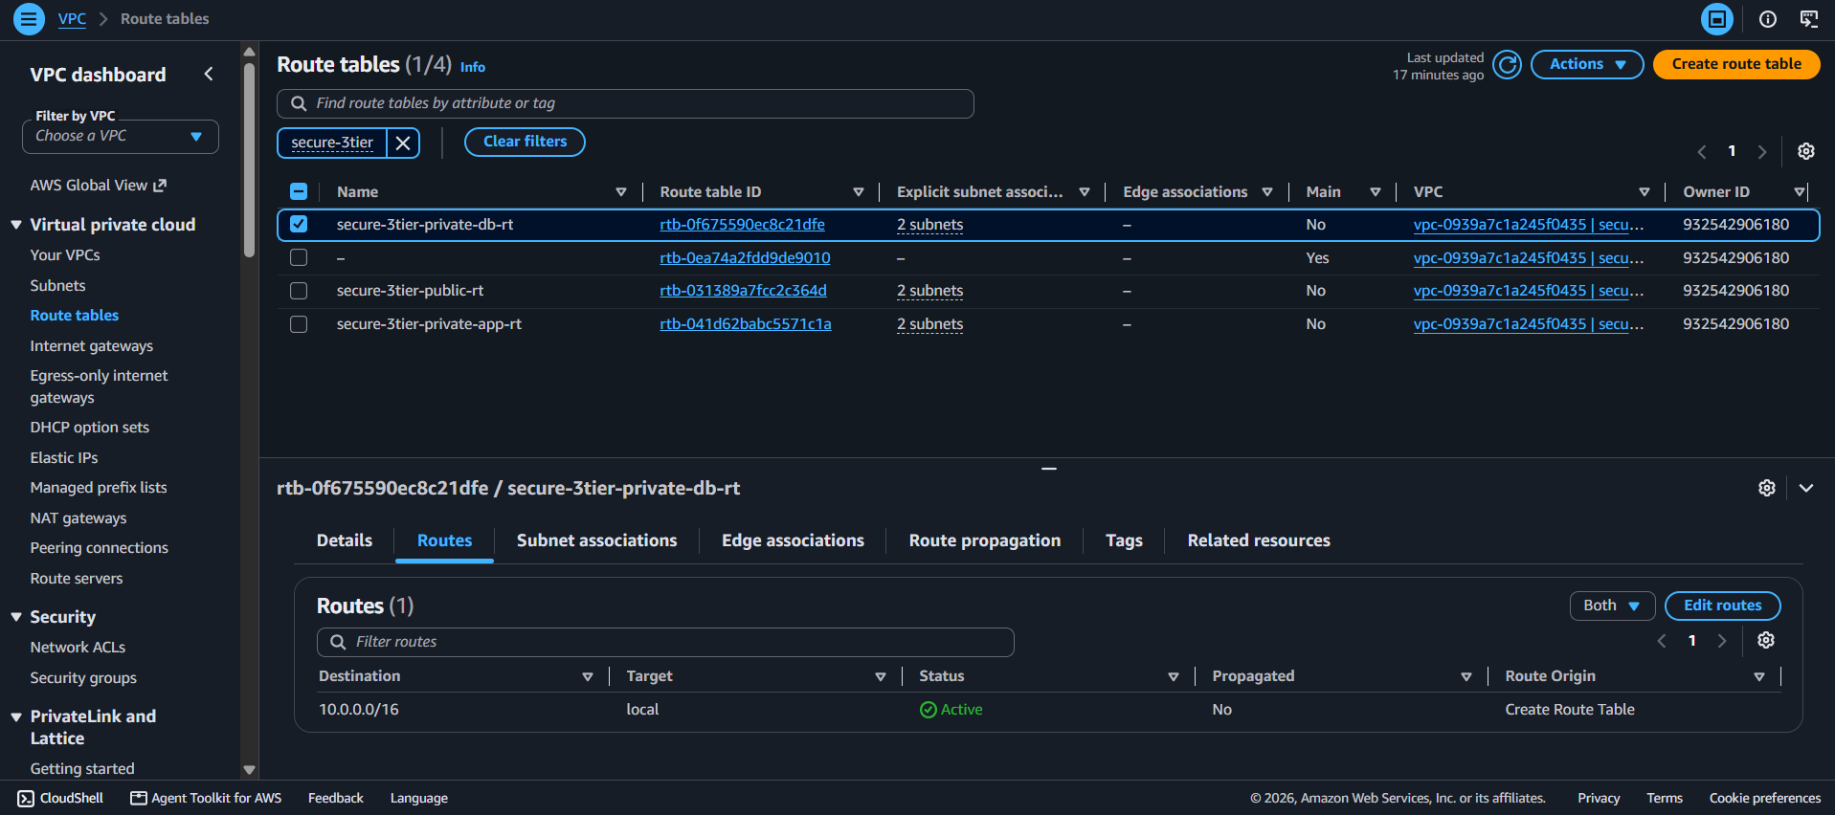
Database route table: only the local VPC route. The database subnets have no path to the internet.

6.3 Load balancer and application server
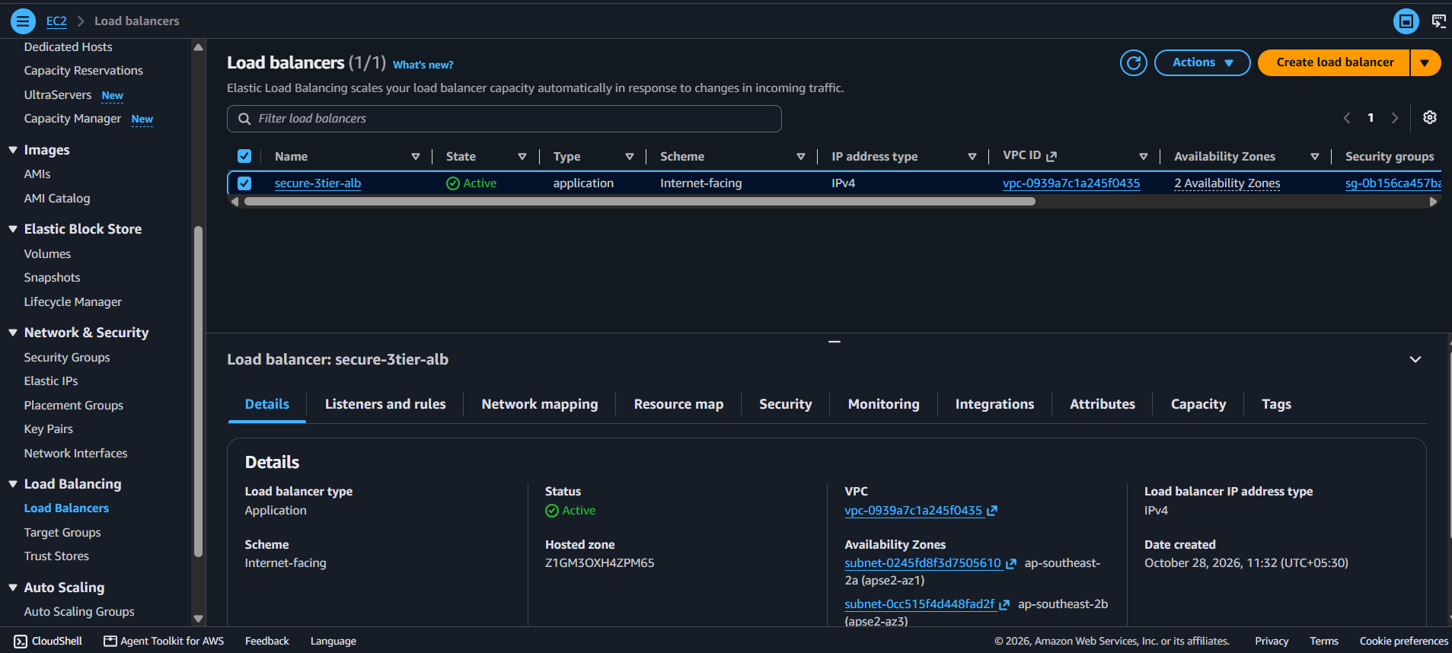
The ALB is internet-facing and Active across two availability zones.
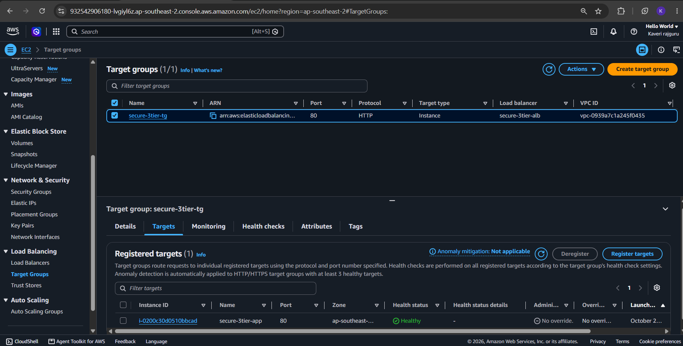
The EC2 instance is registered in the target group and reports Healthy.
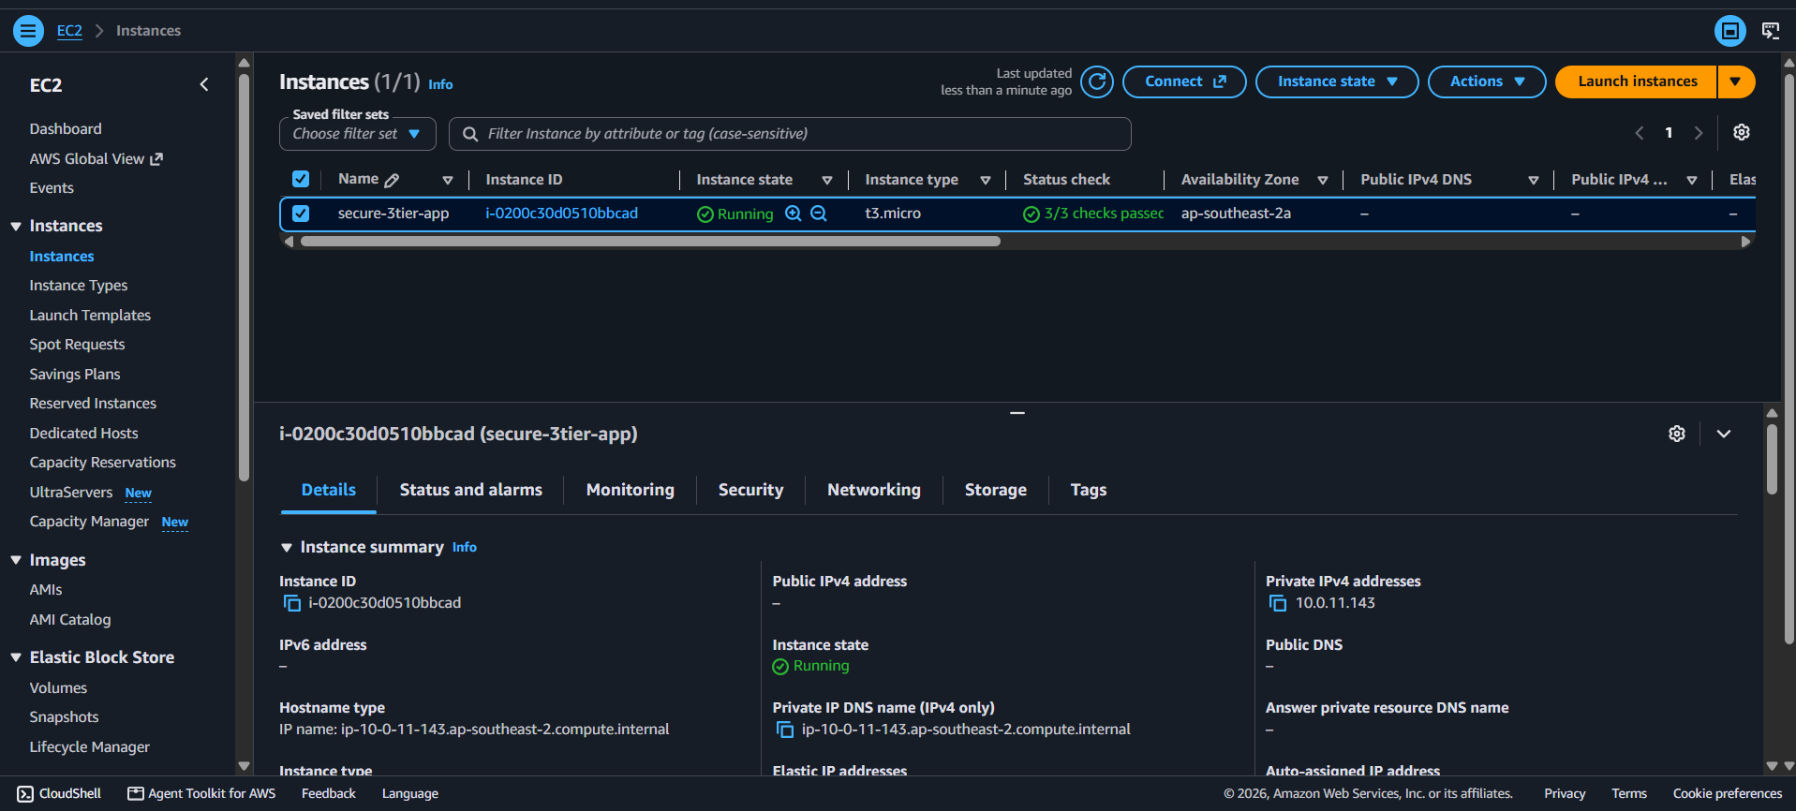
The application server has no public IPv4 address. Its private IP is 10.0.11.143.

6.4 Security groups
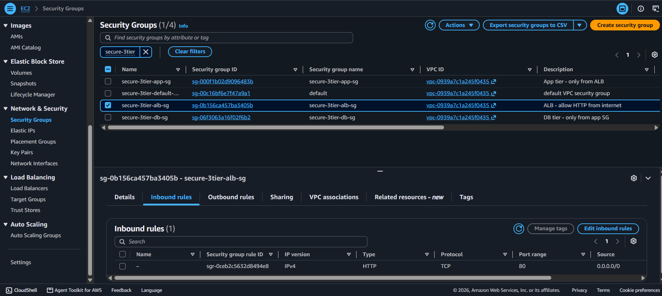
ALB security group: HTTP port 80 from 0.0.0.0/0.
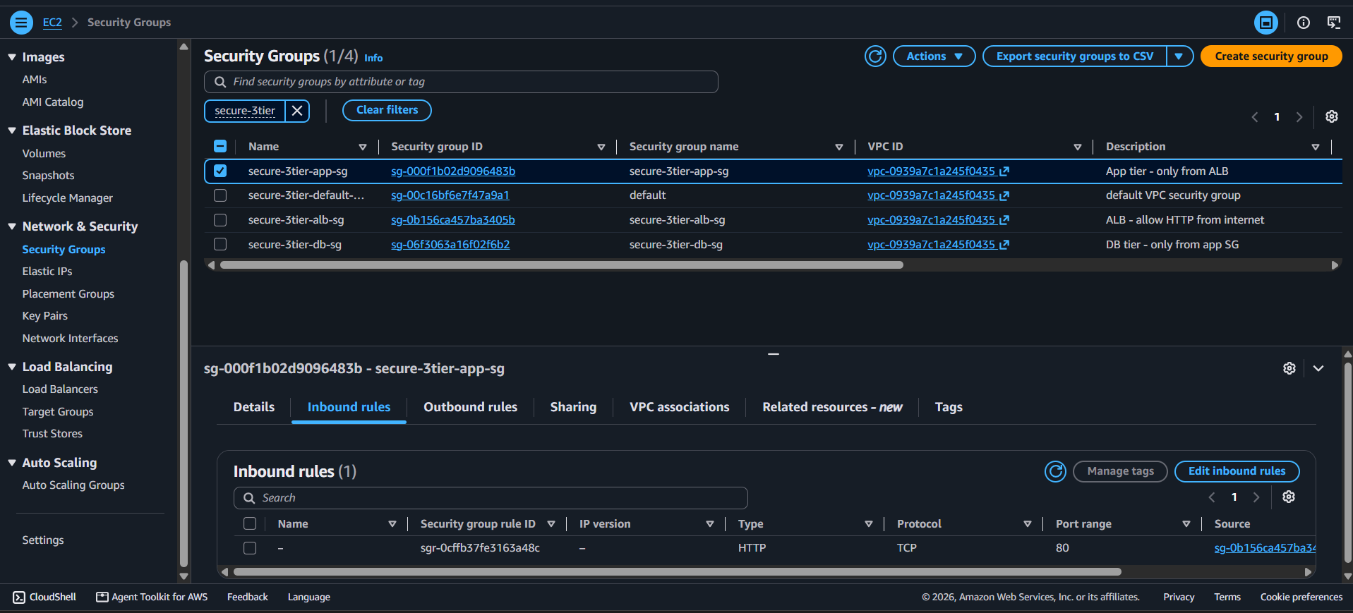
Application security group: port 80 only from the ALB security group.
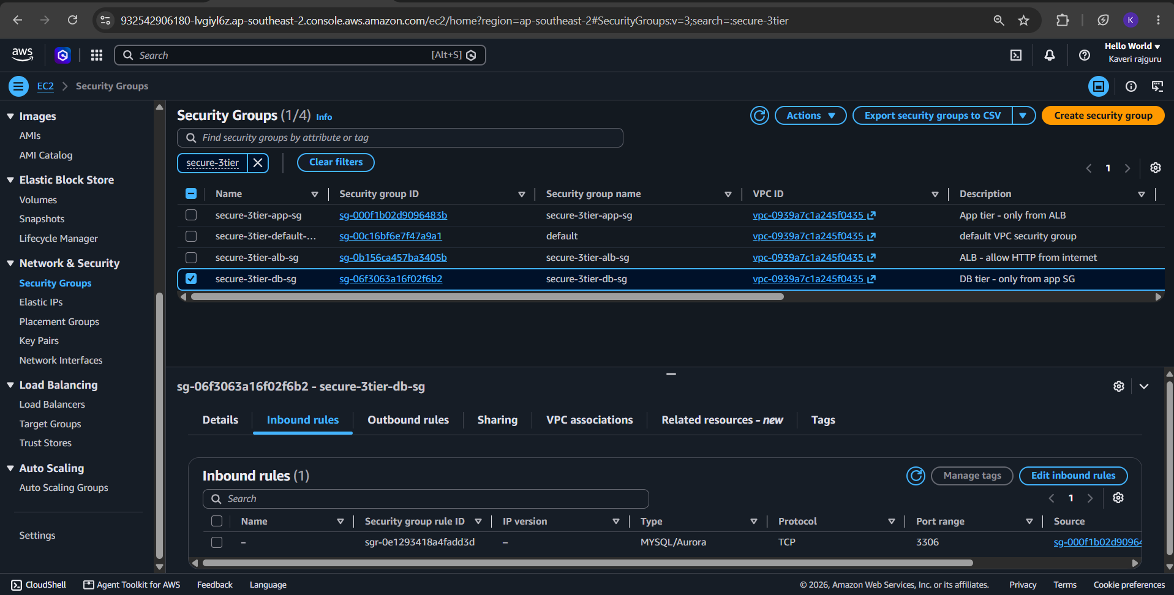
Database security group: MySQL port 3306 only from the application security group.

7. Database Security Evidence
The database is not publicly accessible, is encrypted, and accepts connections only from the application server. This was verified in three ways: configuration, security group rules, and live connection tests from two locations.
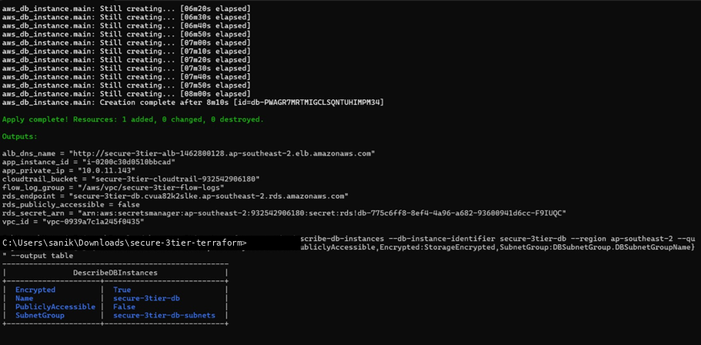
aws rds describe-db-instances reports PubliclyAccessible = False, Encrypted = True and the private DB subnet group.
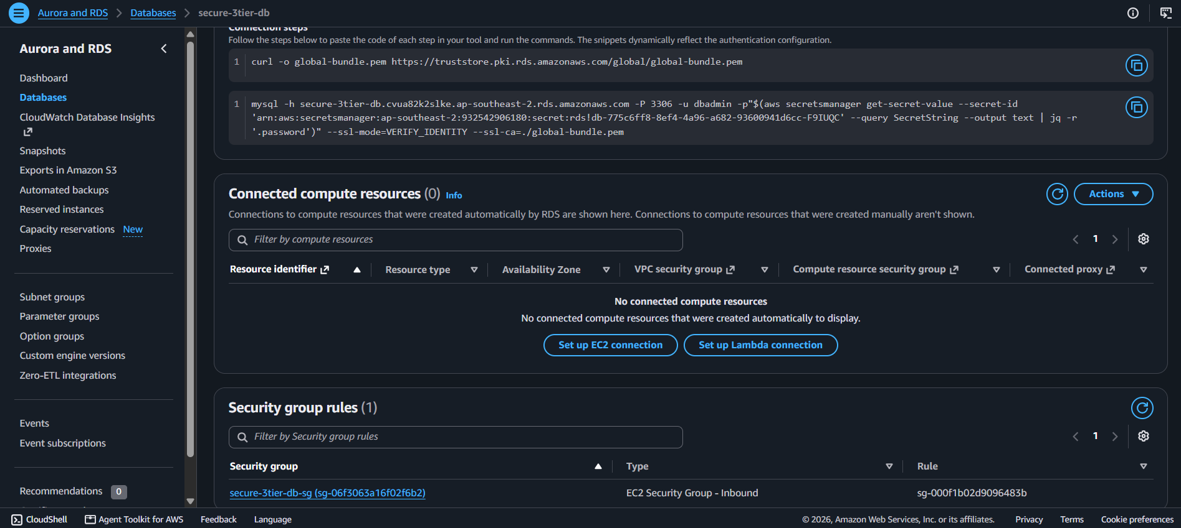
The RDS console lists a single inbound rule on secure-3tier-db-sg, sourced from the application security group.
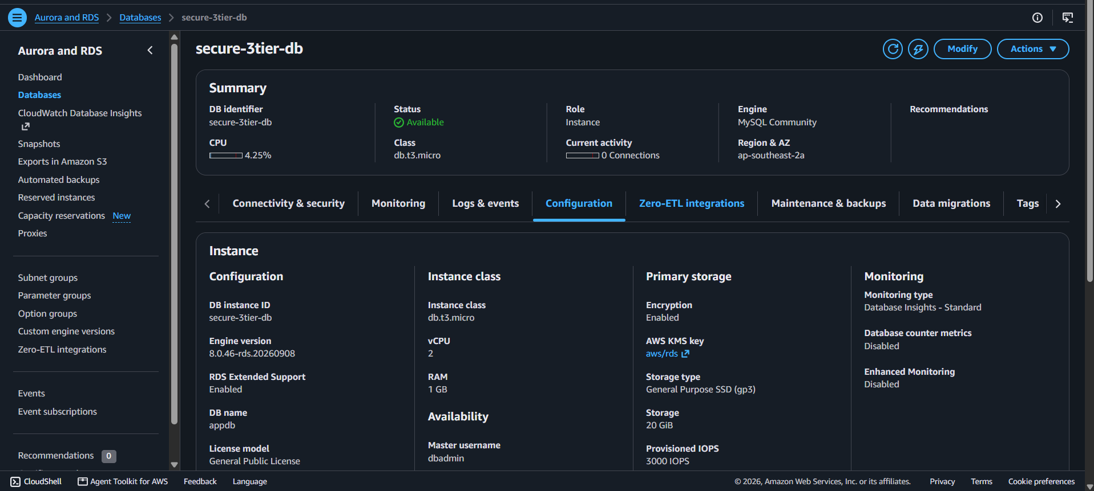
RDS configuration shows storage encryption Enabled with the AWS-managed KMS key (aws/rds), instance class db.t3.micro and 20 GiB of gp3 storage.
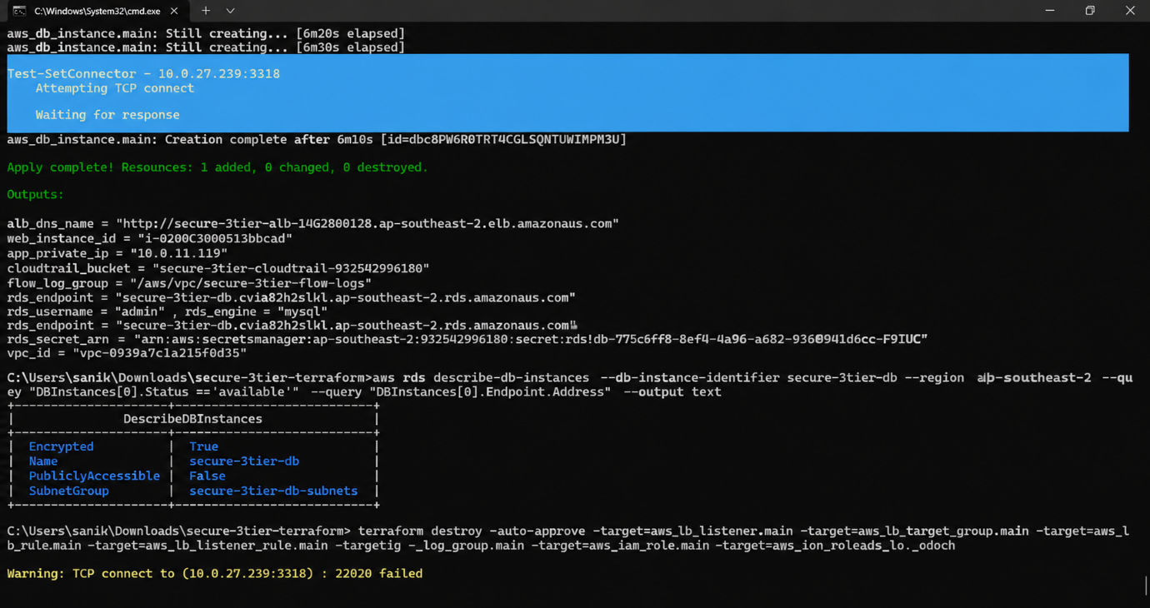 A TCP test from a laptop on the internet to the RDS endpoint on port 3306 fails. The endpoint resolves only to a private address (10.0.21.239) in the database subnet. 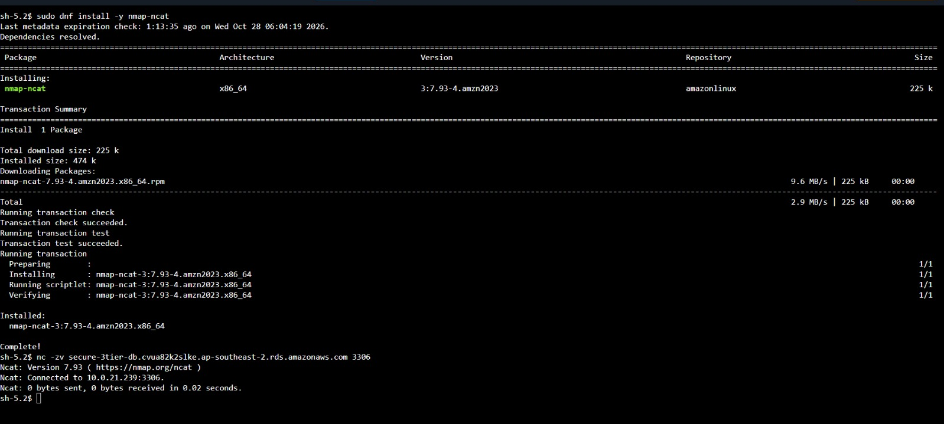

From the application server (reached with Session Manager, no SSH), the same test succeeds: Connected to 10.0.21.239:3306.
The two tests together prove the requirement: the database is unreachable from the internet and reachable only from the application tier.

8. Security Monitoring
Two services provide basic security monitoring: VPC Flow Logs record network traffic, and CloudTrail records every API call made in the account.

8.1 VPC Flow Logs
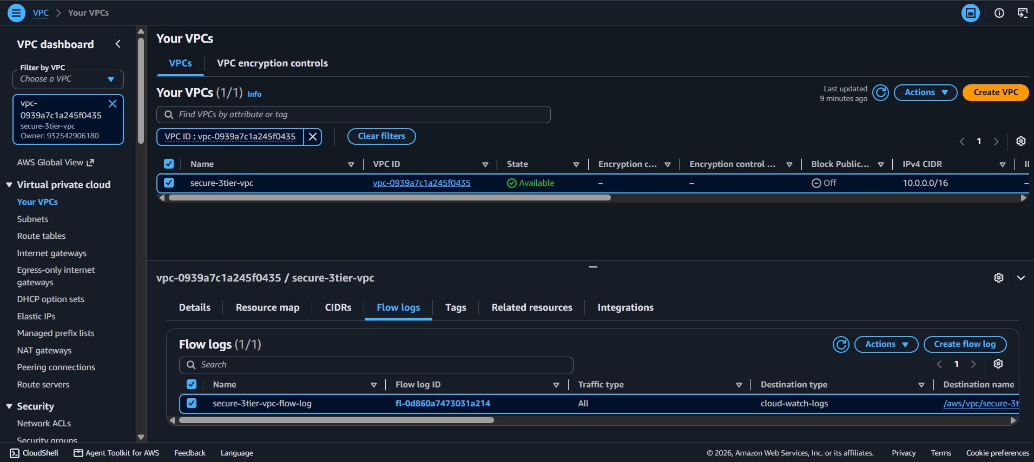
A flow log on the VPC captures ALL traffic and sends it to CloudWatch Logs.
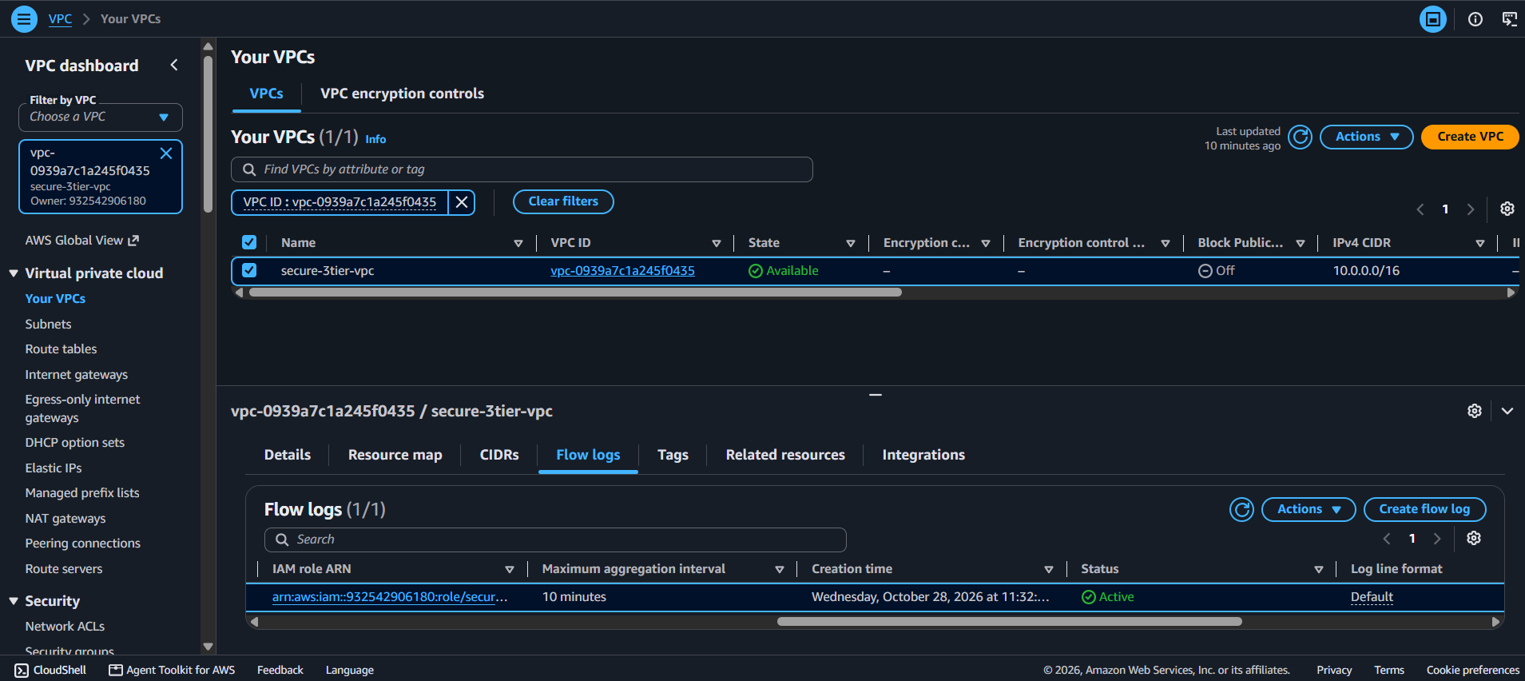
The flow log status is Active with a 10-minute aggregation interval.
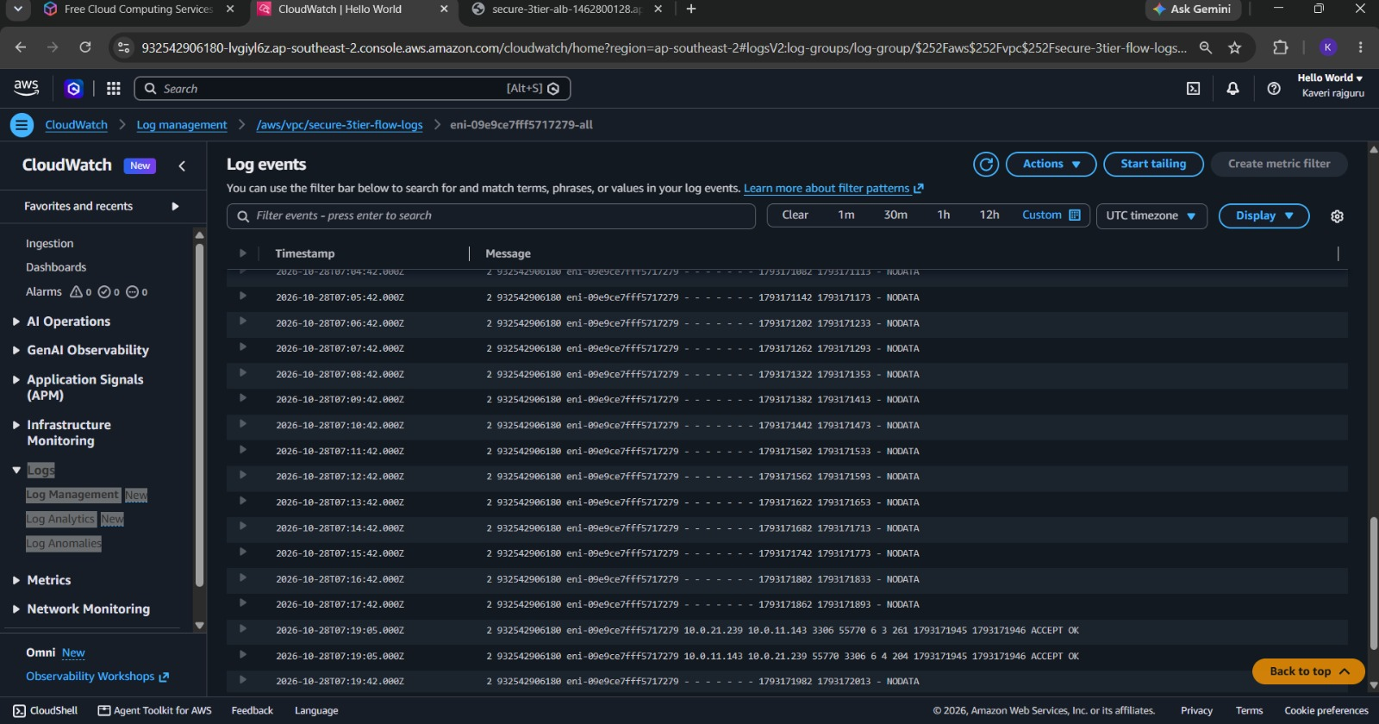Flow log records in CloudWatch. The ACCEPT lines show MySQL traffic on port 3306 between the application server (10.0.11.143) and the database (10.0.21.239), confirming the only permitted path to the database.

8.2 CloudTrail
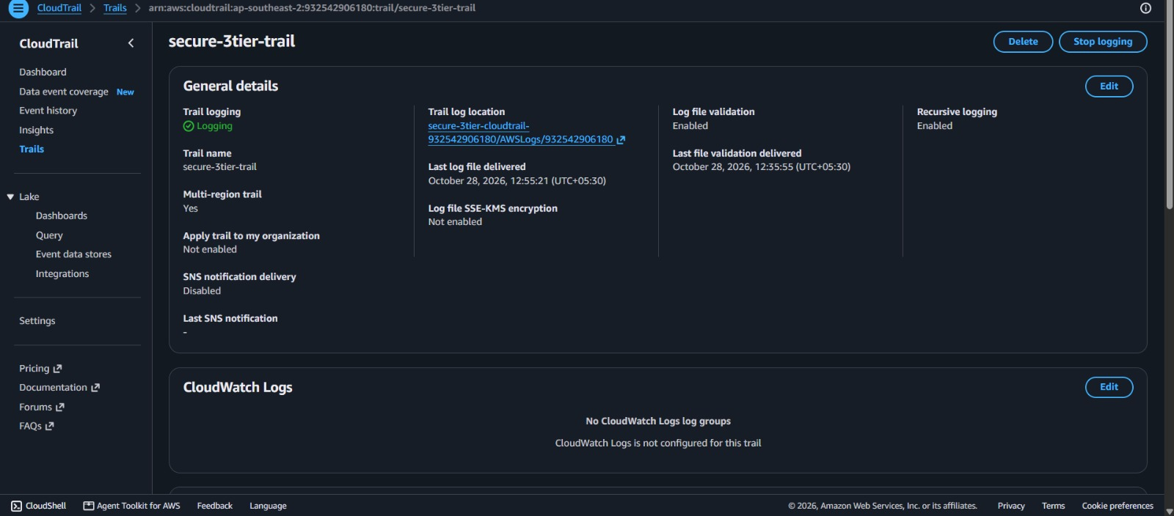
secure-3tier-trail is logging, multi-region, with log file validation enabled and logs delivered to the private S3 bucket.
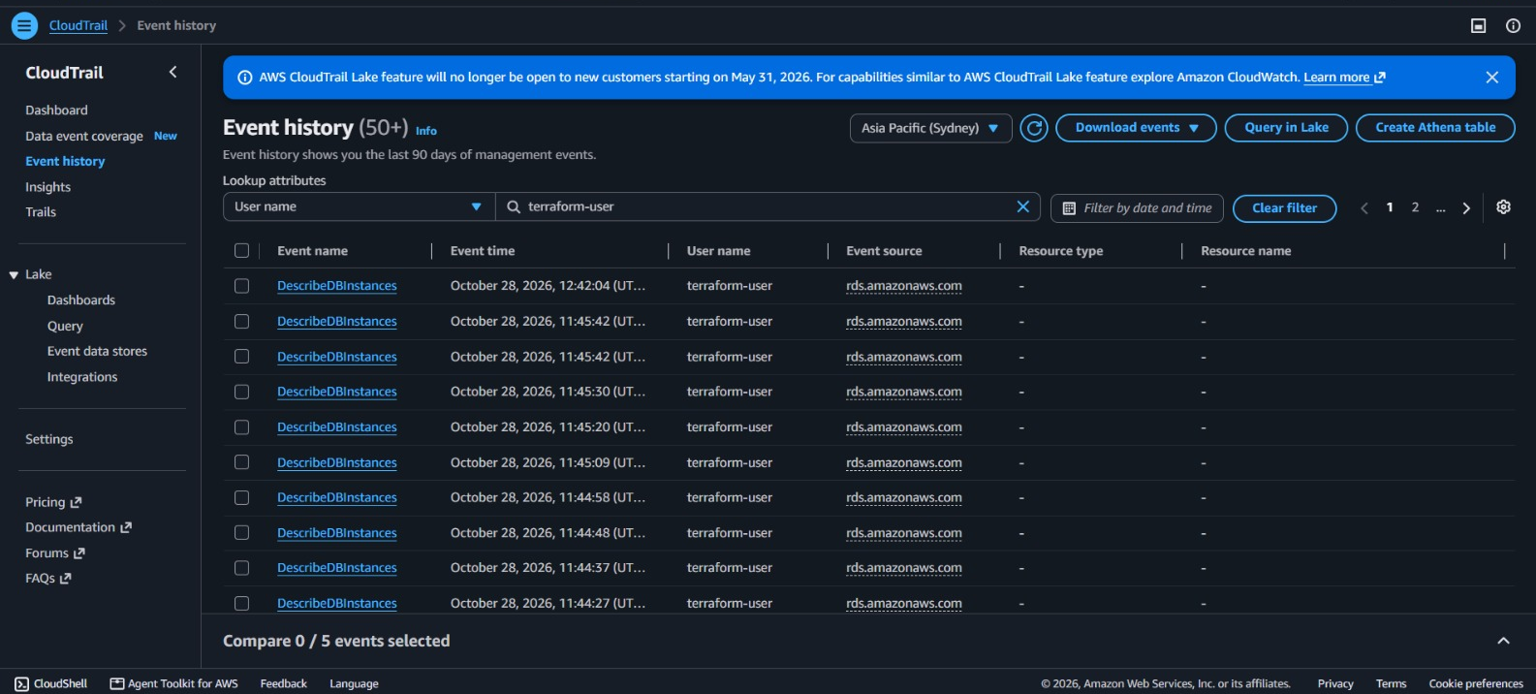
Event history shows API activity by terraform-user, giving a full audit trail of who changed what and when.
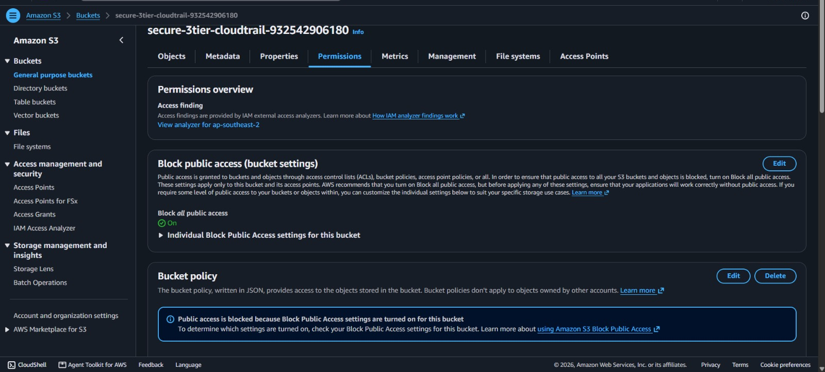
The CloudTrail log bucket has Block all public access turned On, so audit logs cannot be exposed.

9. SECURITY BEST PRACTICES APPLIED
Security is implemented through multiple layers to protect the AWS infrastructure, application server, and database. Different security controls are used to prevent unauthorized access, protect sensitive information, and monitor network activities.
Security Control | Implementation | Risk Reduced
Network Isolation | ALB is deployed in public subnets, while EC2 and RDS are deployed in private subnets without public IP addresses. | Direct internet attacks on servers and databases.
Isolated Database Subnets | Database subnets are configured without direct internet routes. | Unauthorized database access and data exposure.
Least-Privilege Security Groups | Traffic is allowed only between authorized layers: Internet to ALB, ALB to EC2, and EC2 to RDS. | Unauthorized communication between application layers.
Secure Administrative Access | AWS Systems Manager Session Manager is used instead of exposing SSH port 22. | Brute-force attacks and unauthorized remote access.
IMDSv2 Protection | EC2 instances require IMDSv2 tokens for accessing instance metadata. | Unauthorized access to instance metadata and credentials.
Encryption at Rest | EBS volumes, RDS storage, and S3 storage are configured with encryption. | Exposure of sensitive data stored in cloud storage.
Secure Password Management | The RDS master password is generated and managed through AWS Secrets Manager. | Password exposure in source code and configuration files.
Default Security Group Protection | Unnecessary inbound and outbound rules are removed from the default VPC security group. | Accidental exposure of AWS resources.
Audit Logging | AWS CloudTrail records account activities across multiple AWS regions. | Unauthorized changes and lack of activity tracking.
Network Traffic Monitoring | VPC Flow Logs capture network traffic for security analysis. | Lack of visibility into network communication.
Secure Log Storage | The CloudTrail S3 bucket blocks public access and enforces secure HTTPS connections. | Unauthorized access to audit logs.

10. CHALLENGES FACED AND RESOLUTIONS
During the deployment of the AWS infrastructure using Terraform, some configuration and permission-related challenges were encountered. These issues were identified by reviewing Terraform error messages and resolved by modifying the deployment configuration.
Problem | Cause | Resolution
SSM GetParameter Access Denied | AWS Organization security policies restricted access to the public AMI parameter in the initially selected region. | Checked AWS permissions and selected a region where the required AMI parameter was accessible.
EC2 DescribeImages Access Denied | Organization-level restrictions prevented the EC2 image lookup operation in the original region. | Used the permitted AWS region and configured the AMI lookup accordingly.
RDS Free Tier Restriction Error | The selected RDS backup retention configuration exceeded the account's permitted limit. | Changed the backup_retention_period value from 7 days to 1 day in database.tf and applied the updated configuration.
Terraform maintains infrastructure state, so when the configuration was applied again, it created the remaining resources that had not been deployed successfully instead of unnecessarily rebuilding existing resources.
These challenges provided practical experience in understanding AWS permissions, organizational security restrictions, regional configurations, and Terraform state management.

11. COST MANAGEMENT, CLEANUP AND FUTURE IMPROVEMENTS
11.1 Cost Management and Resource Cleanup
AWS resources such as NAT Gateway, Amazon RDS, EC2 instances, and Application Load Balancers may generate charges depending on their usage and configuration.
To avoid unnecessary costs, the infrastructure is removed after completing deployment testing and collecting the required screenshots.
The following Terraform command is used to remove the resources:
terraform destroy
This command deletes the infrastructure managed by the Terraform configuration.
For this laboratory project, settings such as force_destroy for the S3 bucket and skip_final_snapshot for RDS may simplify resource cleanup. However, these settings should be reviewed carefully before using them in production environments because they can result in permanent data loss.
11.2 Future Improvements
The current architecture provides basic security and network isolation. However, additional AWS services and configurations can further improve its performance, security, and availability.
Proposed Improvement | Benefit
Auto Scaling Group | Automatically increases or decreases EC2 instances according to application demand and replaces unhealthy instances.
HTTPS Listener with ACM Certificate | Provides encrypted communication between users and the Application Load Balancer.
Multi-AZ RDS Deployment | Improves database availability and supports recovery during Availability Zone failures.
NAT Gateway in Each Availability Zone | Improves network availability and reduces dependency on a single NAT Gateway.
AWS WAF Integration | Protects the application against common web attacks such as SQL injection and cross-site scripting.
Amazon GuardDuty | Helps detect suspicious activities and potential security threats in the AWS environment.
CloudWatch Alarms | Provides alerts when unusual network traffic or system activity is detected.
CloudTrail with SSE-KMS Encryption | Improves audit log protection through encryption using AWS Key Management Service.
Remote Terraform State Storage | Stores Terraform state securely in an S3 bucket and supports controlled collaboration.
These improvements can make the architecture more scalable, reliable, and suitable for real-world cloud environments.

12. CONCLUSION
The project demonstrates the design and deployment of a Secure Three-Tier Application Architecture on Amazon Web Services (AWS) using Terraform.
The architecture separates the presentation, application, and database layers using public and private subnets. The Application Load Balancer manages incoming user requests, the private EC2 instance processes application traffic, and Amazon RDS provides secure database storage.
Security is implemented through network isolation, Security Groups, route tables, encryption, AWS Secrets Manager, and secure administrative access using Systems Manager Session Manager. VPC Flow Logs and AWS CloudTrail provide additional monitoring and auditing capabilities.
Terraform simplifies infrastructure deployment by allowing AWS resources to be created and managed through configuration files. It also makes the deployment process repeatable and easier to maintain.
Overall, the project provides practical knowledge of AWS cloud infrastructure, network security, database protection, infrastructure automation, and security monitoring. It demonstrates how multiple security controls can work together to build a secure and scalable cloud environment.

Github Link: https://github.com/Iamsanika28/CSA-Capstone-Unit-5.git

